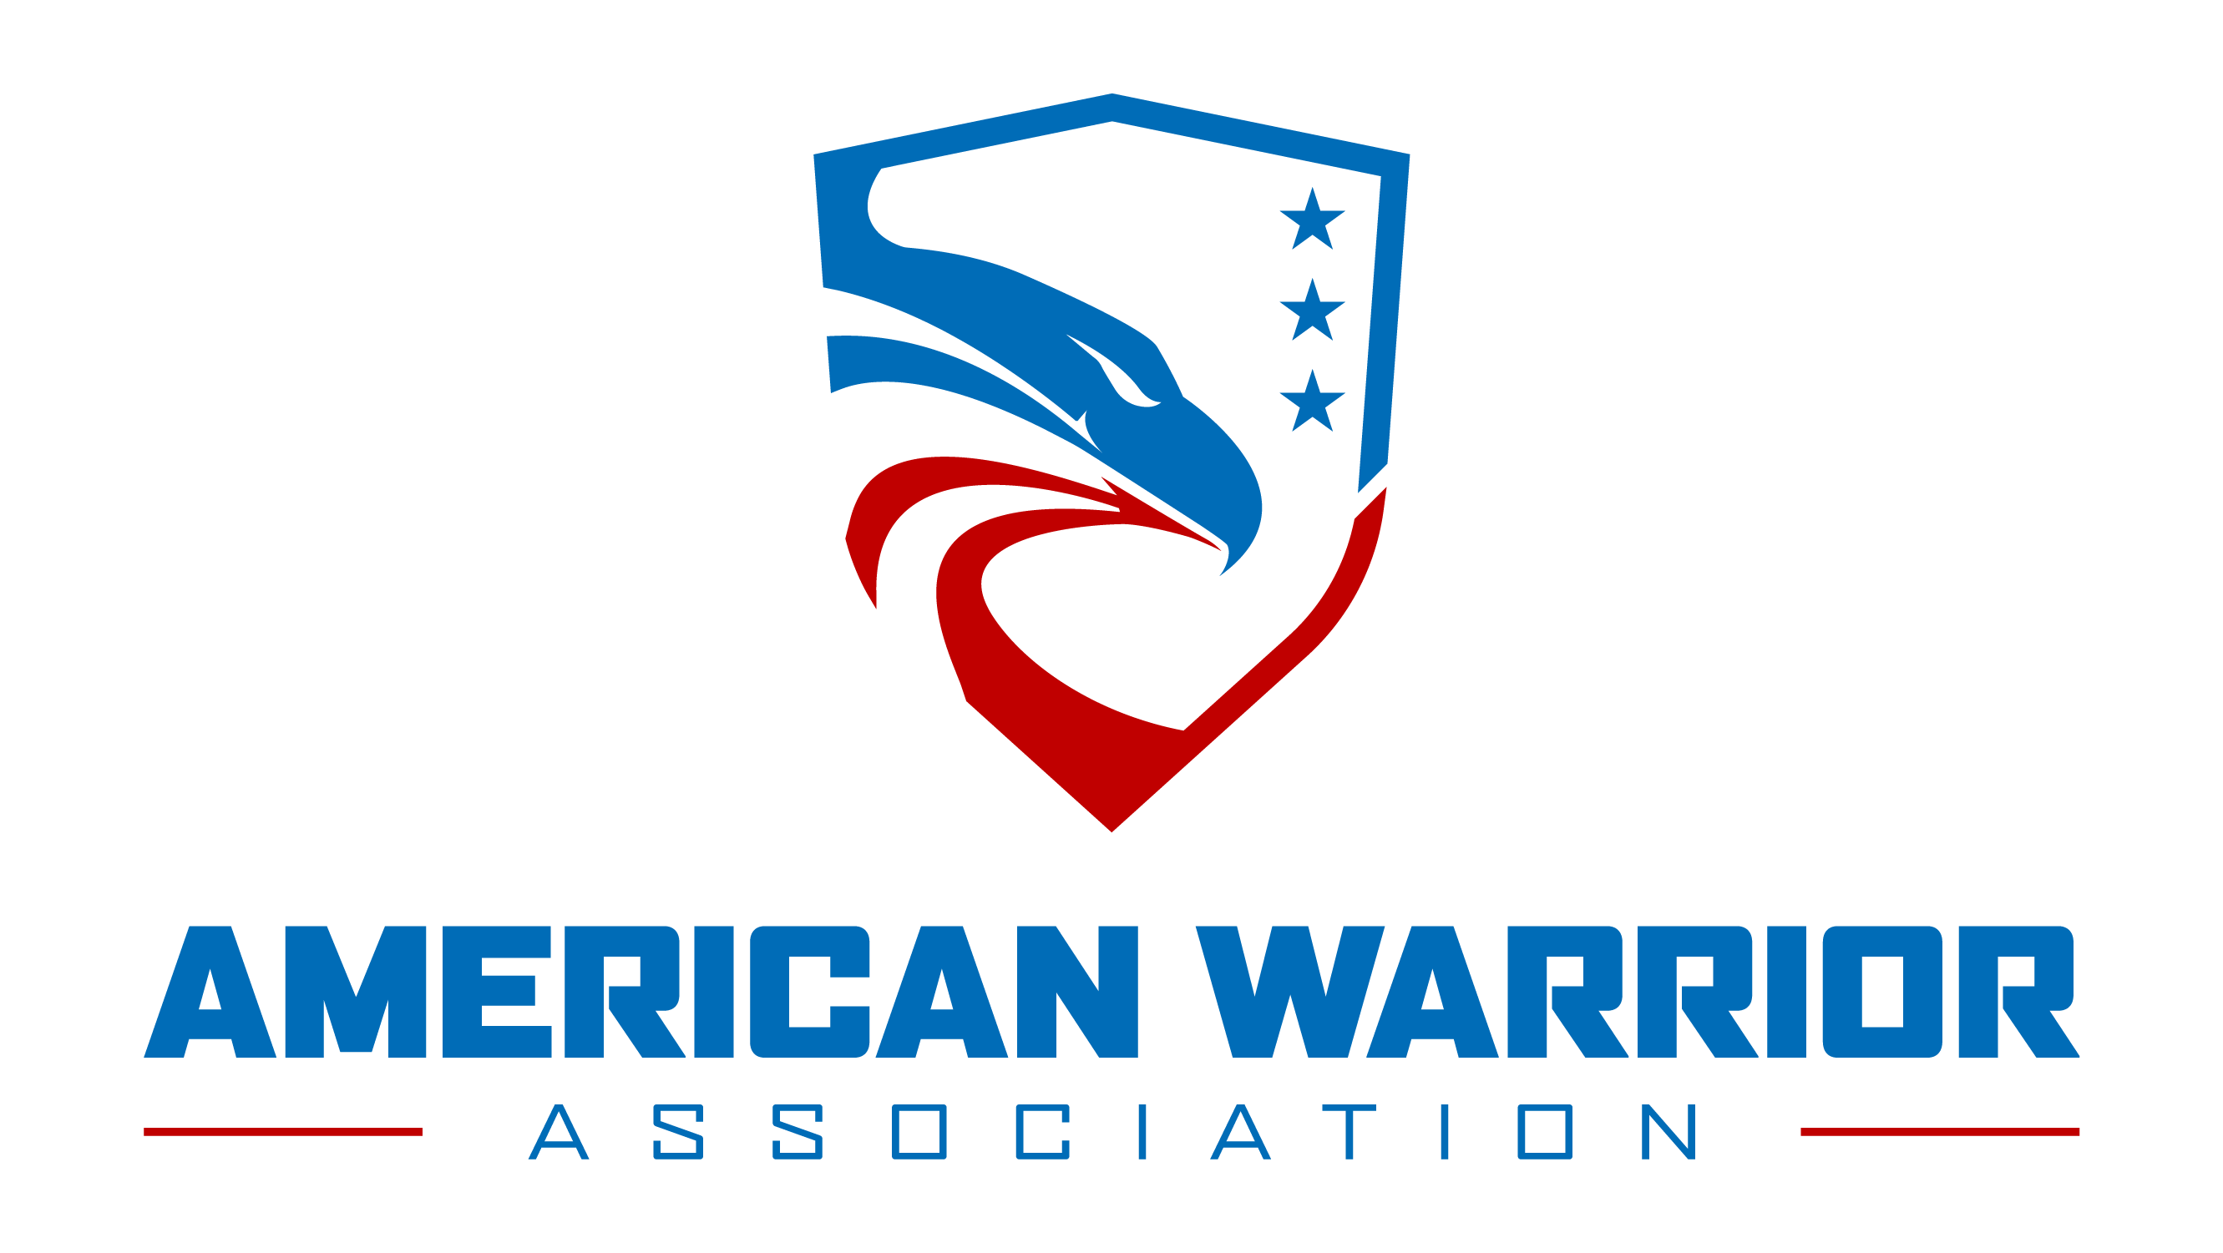

APPLICATION FOR 2021/22 SCHOLARSHIP

Thank you for your interest in the American Warrior Association Tier One, Tier Two and Tier Three Scholarship Program and your continued commitment to Duty, Honor and Country. We are excited to offer this competitive scholarship program to assist in your educational goals while preparing you for a life of purpose helping other Americans in the future. We wish you the best during your application process.
Use this checklist to ensure you have included all of the required materials for the application. INCOMPLETE APPLICATIONS WILL NOT BE ACCEPTED FOR CONSIDERATION, so be sure to carefully fill out the entire application and include all required material.
We thank you for your service to our Nation and for being a part of the American Warrior Association dedicated to geometrically progressing goodness throughout society – it is truly an honor to serve you.
Best regards,
Will Spencer
Executive Director

Thank you for your interest in the SEAL Future Fund Scholarship Program. We are excited to offer this Scholarship Program and wish you the best of luck in your application.

Use this checklist to make sure you have included all of the required materials
for the application. INCOMPLETE APPLICATIONS WILL NOT BE ACCEPTED FOR CONSIDERATION, so be sure to carefully ﬁll out the entire application
and include all required materials.

Thank you for being a part of the SEAL Future Fund family—it is our honor to serve you.

-, CEO
Completed application form

Commitment Essay Recommendation(s) School transcript(s)
Test Score(s)
Proof of enrollment in an accredited college or university for the 2021-2022 academic year

Proof of tuition cost

Proof of income

Proof of honorable discharge

Completed name and materials release form

American Warrior Association 2021 – 2022 Scholarship Application

INTRODUCTION & INSTRUCTIONS

ABOUT THE SCHOLARSHIP

The American Warrior Association (AWA) is proud to announce its annual Scholarship Program. We are offering up to two (2) Tier One Bill Mulder Scholarships worth as much as $15,000 each to qualiﬁed transitioning military or veteran, and Special Operation Forces (SOF) Operators who are enrolled in an accredited top 20 college or university in an MBA, Law or Medical program for the 2020-2021 academic year. We are also offering twenty-five (25) Tier Two and Three Scholarships of $2,000 to $10,000 each to qualified transitioning military or veterans who are seeking to complete their four-year degree or attend a trade school.

Eligibility & Requirements
To be eligible for the Scholarship Program, a candidate must be a transitioning active duty or veteran honorably discharged after December 31st, 2015. Previous recipients of a Scholarship Program award are ineligible.
Applicants must submit all of the following materials:

- Completed application form

- Commitment to Serve

- Recommendation(s)

- School transcript(s)

- Test score(s)

- Proof of enrollment in an accredited college or university for the 2018-2019 academic year

- Proof of tuition cost

- Proof of income

- Proof of honorable discharge

- Completed name and materials release form

Deadline
All application materials must be submitted to the AWA by May 31st, 2021.
APPLICATION INSTRUCTIONS Application form
Please ﬁll out all sections of the application.

Commitment to Serve Essay
Your Commitment to Serve Essay should be between 1000 – 2000 words in length detailing out how you have served others in your community and how you are committed to doing so in the future if awarded an AWA Scholarship.
Document must include the header “AWA 2021 - 2022 SCHOLARSHIP “Commitment to Serve Others” in 18-point, centered text at the top of the page.

Recommendations
Applicants must supply at least one letter of recommendation, depending on their service status:
If you are Active Duty Enlisted, supply one recommendation letter from your Command Master Chief; or CSM/SEA.
If you are Active Duty Officer, supply a recommendation from your Commanding Officer.
If you are a Veteran, you must supply two recommendation letters: One from your current supervisor, and one from a prior teammate (Some exceptions may apply. Please contact us if you cannot supply one of these recommendations.)
Recommendations must include the header “AWA 2021 - 2022 SCHOLARSHIP RECOMMENDATION” in 18-point, centered text at the top of the page.

School transcript(s)
Please supply a certiﬁed transcript from your last attended or completed academic institution(s).

Test score(s)
Please supply certiﬁed score(s) from any relevant undergraduate or graduate aptitude tests (e.g. SAT, ACT, GMAT, LSAT) you have taken.

Proof of academic enrollment
This can be in any of the following forms:
- Cancelled tuition check
- Certiﬁcation of enrollment from the college registrar

Proof of tuition cost
This can be submitted as a copy of your most recent tuition statement from your college or university.

Proof of income
Please supply PAGE 1 ONLY of your 2019/20 federal form 1040, in order to verify your federal adjusted gross income and number of dependents. If you are married but have ﬁled separately, you must also supply this page from your spouse’s federal form 1040.

Proof of honorable discharge
Please provide a copy of your DD-214 showing the nature and type of your discharge from active duty.

Name and materials release form
Please ﬁll out the name and materials release form found at the end of the application. The release form allows you to specify how you would like to be identiﬁed. If you have any questions about how this information will be used, please contact us at patriot@americanwarriorfoundation.org.

SUBMISSION INSTRUCTIONS

Please compile all completed elements and submit by mail as one package to AWA at this address:

American Warrior Association
2020– 2021 Scholarship Program
3304 W 5th Street
Fort Worth, Texas 76107

INTRODUCTION & INSTRUCTIONS (CONT’D)

ADDITIONAL INFORMATION

Selection Criteria and Process
The selection of any scholarship recipient under the Scholarship Program (a “Grantee”) will entail the following:
(a) Any scholarship granted under the Scholarship Program (a “Scholarship Grant”) shall be made without regard to race, religion, national origin, or to political, social, or economic beliefs.
(b) A Grantee must satisfy the aforementioned eligibility requirements;
(c) The Scholarship Committee will select all Grantees;
(d) In selecting a Grantee, the Scholarship Committee will rank applicants based on the following criteria, in no particular order, to the extent applicable:
i. The applicant’s previous academic records;
iI. The applicant’s letters of recommendation;
iiI. The applicant’s statement of faith/essay, in terms demonstrating the applicant’s character and motivation necessary to work hard, seriously continue and complete his or her education and willingness to contribute back to society.
iV. The applicant’s relative ﬁnancial need.
(e) The Scholarship Committee reserves the right not to award any scholarships in a given year if, in the sole discretion of the Scholarship Committee, (i) there are no qualiﬁed applicants or (ii) there is inadequate funding;
(f) No member of the Scholarship Committee or the Board of Directors of AWA shall be in a position to derive a private beneﬁt, directly or indirectly, if certain potential Grantees are selected over others;
(g) No Scholarship Grant may be made if the Scholarship Grant shall in any way be inconsistent with AWA’s mission; and
(h) No Scholarship Grant may be made if the Scholarship Grant shall provide an economic beneﬁt to person who has made a charitable contribution to AWA.

Requirements for the Use of the Scholarship
A Scholarship Grant shall be used for the payment of: tuition and fees required for the enrollment or attendance of a Grantee in an accredited degree granting program at a post-secondary educational institution that appears in the U.S. Department of Education’s Database of Accredited Postsecondary Institutions and Programs (https://ope.ed.gov/accreditation/) (a “Quali- ﬁed Educational Institution”); and/or fees, books, supplies, and equipment required on the part of the Grantee for courses of instruction associated with a degree granting program at such Qualiﬁed Educational Institution.
The Scholarship Committee shall require a Grantee to provide proof of appropriate usage of any Scholarship Grant funds consistent with such Grantee’s scholarship application, including, but not limited to, permitting the Scholarship Program to pay
Scholarship Grant funds directly to the Qualiﬁed Educational
Institution that the Grantee attends or plans to attend.
At a minimum, a Grantee must maintain a cumulative “B” aver- age, which shall be a grade point average of 3.0 on a scale of
4.0, or an equivalent average on any other scale. The Grantee shall provide the AWA an official copy of his or her school transcript no later than (60) days after the ﬁnal day of the academic year. If a Grantee does not maintain a cumulative “B” average or fails to provide the AWA with a transcript, the Scholarship Committee shall take all reasonable and appropriate steps to recover the Scholarship Grant, unless the Grantee petitions the Scholarship Committee and presents evidence of severe hardship or extenuating circumstances and explains how such circumstances affected his or her grade point average. The Scholarship Committee may, in its discretion, consider whether such circumstances justify the Grantee’s continued use of Scholarship Grant.
In cases in which the Scholarship Committee determines that any part of a Scholarship Grant has been used for improper purposes and the Grantee has not previously diverted Scholarship Grant funds to any use not in furtherance of a purpose speciﬁed in the Scholarship Grant, the Scholarship Committee shall take all reasonable and appropriate steps to recover the Scholarship Grant.
The issuance of any Scholarship Grant by the AWA pursuant to this application will be in conformity with the requirements of the Internal Revenue Service, and the funding of any Scholarship Grant remains subject to, and will only be made upon, the approval of the AWA, Inc. Scholarship Program by the Internal Revenue Service.

Privacy notice
All information provided in connection with the application will be maintained in conformity with the AWA, Inc. Scholarship Program and applicable law concerning its retention.

APPLICATION FOR 2021 - 2022 SCHOLARSHIP

NAME
SSN

LAST

FIRST MI

CONTACT INFO

STREET ADDRESS PHONE

CITY STATE
ZIP
EMAIL

1. EDUCATION

HIGHEST EDUCATION LEVEL ACHIEVED TO DATE

High School/GED Some College Associates Degree Bachelor’s Degree Master’s Degree Other

SCHOOL ENROLLED IN FOR 2019-20 ACADEMIC YEAR

2. SERVICE INFORMATION

SERVICE DETAILS SERVICE HISTORY

BUD/S CLASS/MOS//SPECIALTY NUMBER/LOCATION OF DEPLOYMENTS

DATE ENTERED MILITARY (MM/YY)

DATE ENTERED SOF (MM/YY)

EAS EOS

DATE OF EAS/EOS (if applicable)

AWARDS

APPLICATION FOR 2021 – 2022 SCHOLARSHIP

3. CAREER

FIELDS OF INTERESTS

Finance Technology Politics/Lobbying Government/Civic Legal practice

Non-Proﬁt Education Media/Public Relations Arts/Cultural Medicine/Research

Other (please describe)

4. FINANCIAL INFORMATION

TOTAL HOUSEHOLD INCOME (INCL. SPOUSE)

SPOUSE

DEPENTENTS

TOTAL SIZE OF HOUSEHOLD

2020

EXPECTED 2021 Same as 2020

Y/N

NUMBER

NUMBER, INCL. YOURSELF

COST OF TUITION EXTRAORDINARY FINANCIAL CIRCUMSTANCES

PER SEMESTER E.G. MEDICAL EXPENSES, EXTENSIVE TRAVEL REQUIREMENTS

5. Commitment to Serve Others Please answer the below essay question. See instructions for details
Question: Describe what principles you believe in, how you have helped others in the past and your commitment/willingness to do so in the future. Please include a personal statement of your commitment to geometrically progress goodness in society by helping your fellow Americans. The American Warrior Association believes in the unselfish service to others in an effort to uplift all Americans.

I hereby certify that that the above information is true, to the best of my knowledge, and that I have read all the rules and regulations for
eligibility to receive AWA scholarship funding and agree to comply with them.

SIGNATURE DATE
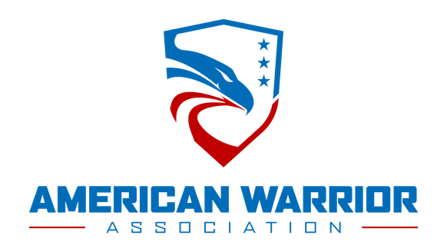

NAME AND MATERIALS RELEASE FORM (“RELEASE”)

For good and valuable consideration, the sufficiency of which I hereby acknowledge, I hereby grant the American Warrior Association, Inc. (“AWA”) the absolute right to use, reproduce, modify, aggregate, disseminate, create derivative works from and otherwise exploit (collectively, “Use”) any non-personally identiﬁable information, including without limitation, essays or portions thereof, contained in any application materials I submit to AWA (collectively, “Material”), in all cases in perpetuity, in any media now known or hereafter devised, and for any purpose whatsoever. In addition, I hereby grant AWA the absolute right to Use (please check one of the following):

My full name

My ﬁrst name and my last initial

My ﬁrst and last initials only

(collectively, “Name”) in connection with the Material, in all cases in perpetuity, in any media now known or here- after devised, and for any purpose whatsoever.
I hereby represent and warrant that: (i) I am at least the age of 18 or majority, whichever is older, in my state of residence; (ii) I have the full power and authority to enter into this Release and grant the rights set out herein for no additional payment; (iii) the Material is entirely my original work; and (iv) the Material will not violate any law, rule or regulation, or infringe, misappropriate or otherwise violate the rights of any third party.
I hereby release and discharge AWA from any liability or claim arising by virtue of any Use or alteration of the Material or Name, whether in whole or in part, including without limitation, any claims for moral rights of any description, defamation, libel, slander, invasion of privacy or right of publicity, infringement, misappropriation or fees for any uses. I further agree to indemnify and hold harmless AWA from any and all claims, damages, liabilities and/or expenses (including attorneys’ fees and expenses, including any incurred in enforcement of this indemnity) resulting from my breach of this Release or its Use of the Material or Name. I acknowledge that I have carefully read this document in its entirety and understand that it is a release of claims and a waiver of liability regarding the Material and Name. In no event shall I be entitled to enjoin, restrain or seek to enjoin or restrain the Use of the Material, Name or any of the rights granted to AWA by this Release.
This Release and any related claim or dispute, whether in contract, tort or otherwise, shall be governed by the laws in effect in the State of Texas, without giving effect to its conﬂicts of law principles. Each party irrevocably consents and agrees to the exclusive jurisdiction of the Texas state or federal courts, as applicable, located in Texas County. EACH PARTY WAIVES, TO THE FULLEST EXTENT PERMITTED BY LAW, ANY RIGHT TO TRIAL BY JURY IN ANY ACTION, SUIT, CLAIM OR PROCEEDING BROUGHT TO ENFORCE, DEFEND OR INTERPRET ANY RIGHTS OR REMEDIES ARISING HEREUNDER, RELATING TO OR IN CONNECTION WITH THIS AGREEMENT. This Release supersedes all prior and contemporaneous agreements and understandings, express or implied, oral or written, between the parties relating to the subject matter hereof.

Name:
Signature:

Date signed:
Age & DOB:

Address (Street, city, state, zip):

Phone (day):
Phone (evening):

AMERICAN WARRIOR ASSOCIATION || 3304 W 5th Street• Fort Worth, TX 76107 || patriot@americanwarriorassociation.org
The American Warrior Association is a 501(c)(3) non-profit organization. Tax ID# 82-4397332

